What are the Indicators of a good quality preschool service?

High quality early childhood care and education can have any long term benefits for children and their families. International research identifies early childhood as a vital period in laying strong foundations for children’s wellbeing, learning and development.
The indicators of good quality are as follows:
- Quality interactions
- Good policies and procedures
- Appropriate child : staff ratios
- Lots of outdoor space and opportunities to explore the outdoors
- Variety of indoor play activities
- Planned curriculum/activities incorporating the child’s emerging interests
- Play and hands-on experiences
- Child observations
- Good partnership with parents
- Child friendly environment
- Qualified and experienced staff
- Ongoing professional development of staff
How do I apply for AIM?
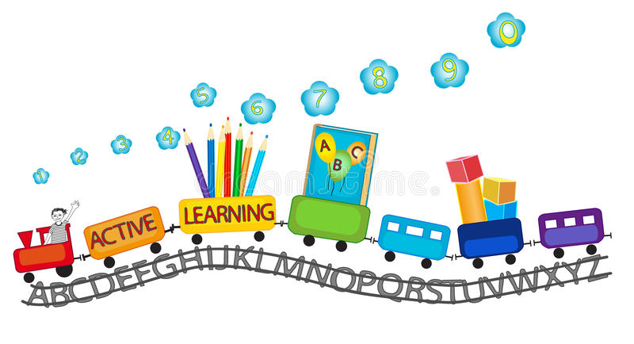
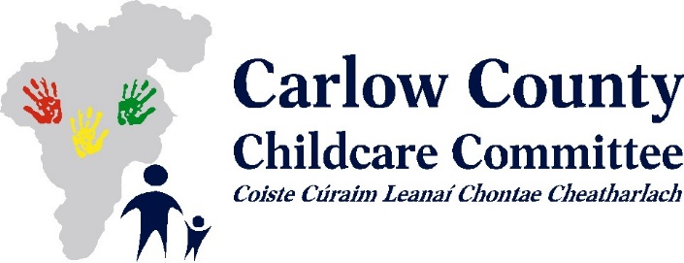
Are there any additional supports for children with special educational needs?

Yes, In 2016 the Better Start Access and Inclusion Model (AIM) was introduced, It offers tailored, practical supports based on need and does not require a formal diagnosis of disability. There are seven levels of progressive support, moving from universal to the targeted, based on the needs of the child and the preschool provider.
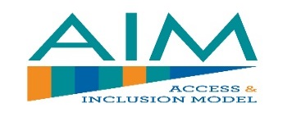
AIM supports all children in accessing and fully participating in the ECCE programme through empowering service providers to deliver an inclusive preschool experience. AIM supports services by offering training, expert advice, mentoring and support from a team of 50 specialists, specialised equipment, appliances and grants towards minor building alterations and additional capitation to fund extra support in the classroom or to enable the reduction of the staff:child ratio.

If required, the service provider will collaborate with you in identifying additional supports needed to ensure your child’s participation in preschool, the preschool service provider can then apply with your consent for the targeted supports under AIM.
Further information on AIM can be found at: http://aim.gov.ie/

Parent Information

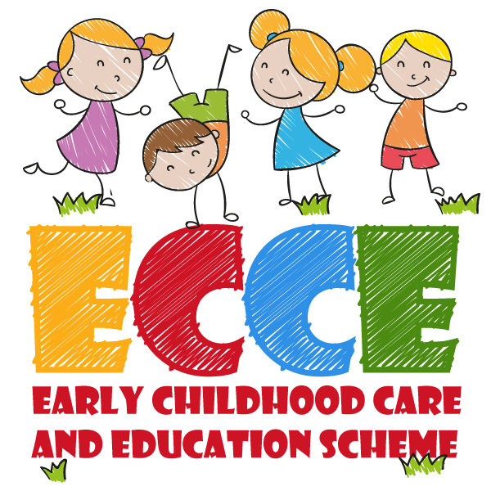

What is the Early Childhood Care and Education (ECCE) Scheme?

The Department of Children and Youth Affairs (DCYA) provides funding for the Early Childhood Care and Education (ECCE) Scheme which offers a free 3 hour preschool place, 5 days a week, 38 weeks per year for children of preschool age, this place may be offered in a sessional service or incorporated into part time/ full time service provision.
From September 2018, children are eligible for ECCE once they are 2 years and 8 months by the 31st August 2018 and are entitled to 2 full academic years or 76 weeks from September 2018 before commencing primary school provided that they are not older than 5 years 6 months at the end of the preschool year.
Check your child’s eligibility in the ECCE calculator on our website at www.carlowccc.ie, or see below.
To avail of the ECCE programme with effect from | Children must have been born between the following dates (both dates inclusive)
September 2018 – June 2019 | 1st January 2014 – 31st December 2015
September 2019 – June 2020 | 1st January 2015 – 31st December 2016
September 2020 – June 2021 | 1st January 2016 – 31st December 2017
Is there a booking deposit?

The service may ask you for a booking deposit to hold an ECCE place, this must be repaid to you by the end of October of the year your child starts ECCE.
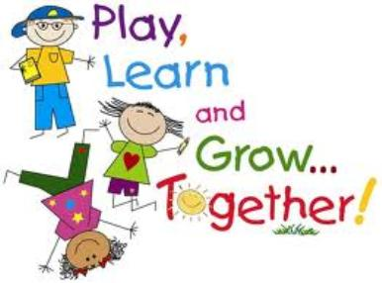
Will I have to pay any additional charges?

Services which participate in the scheme must provide the ECCE hours free of charge, however, additional hours or part hours which parents choose to avail of outside of the ECCE session may occur a charge.
Services may only charge parents for optional extras such as trips, specialised exercise, music and dance classes which are not part of the everyday curriculum. These services are optional to you and may occur an additional charge. The service must provide an appropriate alternative activity for your child if you choose to opt out of these classes.
If you are unhappy or unsure with any aspects of the scheme, please contact Carlow CCC to discuss any concerns you may have in confidence.
How do I enrol my child for the free Early Childcare Care and Education (ECCE) Scheme?

Make contact with your preferred childcare facility to see if they have a place available and fill out the relevant documentation. You will need to provide a copy of your child’s birth certificate or passport and PPS number.
For further information on the ECCE scheme including programme rules please visit www.dcya.gov.ie.
A list of preschool services in Carlow participating on the ECCE scheme is available from Carlow County Childcare Committee (CCCC) on:
W: www.carlowccc@ie E: info@carlowccc.ie
Telephone: 059 9140244
