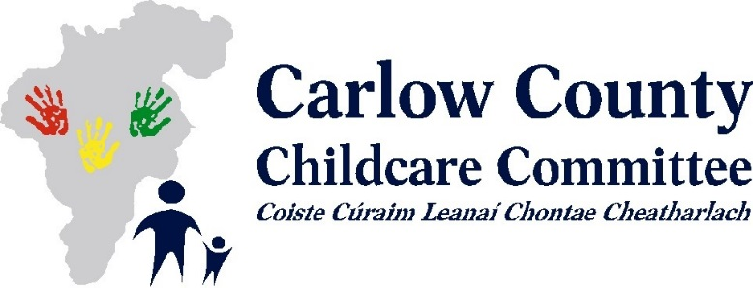

***Training Calendar September - December 2019***

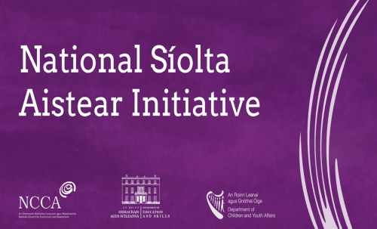***Purpose***

* ***To increase understanding of, and familiarity with, the structure and content of the Aistear Síolta Practice Guide.***
* ***To begin to consider how you could use the resources in the Practice Guide to develop your curriculum further.***

|  |  |  |
| --- | --- | --- |
| **Date** | **Workshop** | **Workshop Content** |
| **Aistear Siolta & Practice Guide- An Introduction** | **Wednesday 11th September 2019**  **6.00pm – 9.00pm** | **This workshop will support participant’s understanding of and familiarity with Siolta, Aistear and Aistear Siolta Practice Guide and applying both frameworks to everyday practice.** |
|  |  |  |
| **Introduction to Aistear Siolta Practice Guide** | **Monday 7th October 2019**  **6.00pm – 9.00pm** | **This workshop will support participant’s understanding of and familiarity of using the Aistear Siolta Practice Guide and using the different resources effectively to support developing their curriculum further.** |



**Phase 2 Training – IT system**

**Wednesday 25th September 6.00 – 9.00pm**

**Friday 27th September 1.00 – 4.30pm**

**Tuesday 1st October 1.00 – 4.30pm**

**Tuesday 1st October 6.00 – 9.00pm**

**Thursday 3rd October 1.00 – 4.30pm**

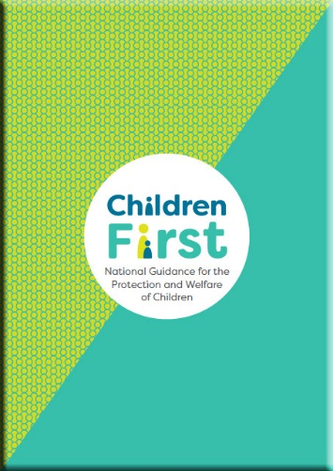 **Always Children First Foundation Training**

1) Tuesday 15th October 9.30am - 4.30pm

or

2) Friday 22nd November 9.30am – 4.30pm

**A prerequisite of attending this training is that participants have completed the Tusla E Learning Children First Programme and CCC’s will ask that participants send a copy of their cert to the CCC prior to attending the training.**

**Diversity, Equality and Inclusion Training**

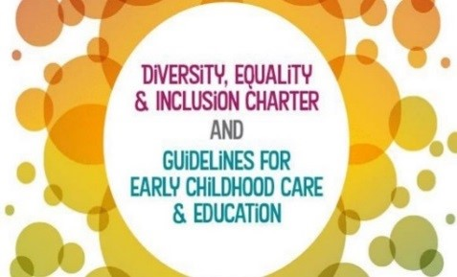**The National Training Programme provides practitioners with an opportunity to explore the concepts of Diversity and Equality within the preschool context and will support participants in the development of an inclusive early years environment for all children.**

Saturday 9th November 9.30am – 4.30pm

Thursday 14th November 6.15pm – 9.15pm

Wednesday 20th November 6.15pm – 9.15pm

Tuesday 26th November 6.15pm – 9.15pm

***Please note: Participants must attend all four training sessions.***

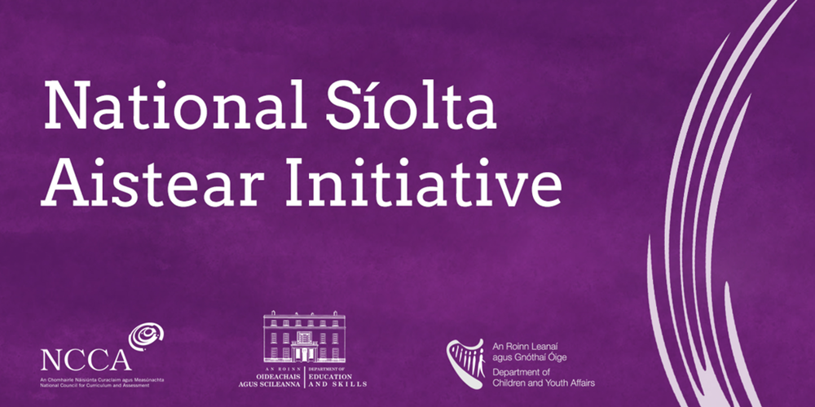

A series of 4 Síolta training workshops (details outlined below) as part of the **National Síolta Aistear Initiative.**

This programme aims to support you in becoming more familiar with *Síolta, the National Quality Framework for Early Childhood Education* and aid you and your team to effectively use the framework to develop and maintain high quality practice in all aspects of your service.

If your service wishes to attend this programme we ask that you sign up as a team, with **at least two members of staff attending EACH session** (this can be adjusted for smaller teams). *In order for the programme to be of most benefit to your service, we would recommend that attendance at these sessions be spread across your staff team based on individual roles and particular interests.*

|  |  |  |
| --- | --- | --- |
| Session: | Síolta Standards covered: | Date, Time + Venue: |
| **Session 1:** This workshop will be of particular relevance to practitioners & managers. | **Standards 2, 6  & 7** (Environments, Play & Curriculum) | **Thursday 10th October**  **6.00-9.00pm**  Conference Rm, Enterprise Hse, O’Brien Rd, Carlow |
| **Session 2:** This workshop will be of particular relevance to practitioners & managers. | **Standards 13,14 + 16** (Transitions, Identity + Belonging & Community Involvement) | **Wednesday 23rd October**  **6.00-9.00pm**  Conference Rm, Enterprise Hse, O’Brien Rd, Carlow |
| **Session 3**: This workshop will be of particular relevance to practitioners & managers. | **Standards 1, 3, 4 + 5**  (The rights of the child, Parents & Families, Consultations + Interactions) | **Wednesday 6th November**  **6.30-9.30pm**  Conference Rm, Enterprise Hse, O’Brien Rd, Carlow |
| **Session 4:** This workshop is of particular relevance to ***Managers and Management teams*** | **Standards 4, 8, 9, 10, 11, 12 +15** (Consultations, Planning & Evaluation, Health & Welfare, Organisation, Professional Practice, Communication + Legislation & Regulation) | **Tuesday 12th November**  **2.00-5.00pm**  Conference Rm, Enterprise Hse, O’Brien Rd, Carlow |