**+**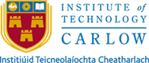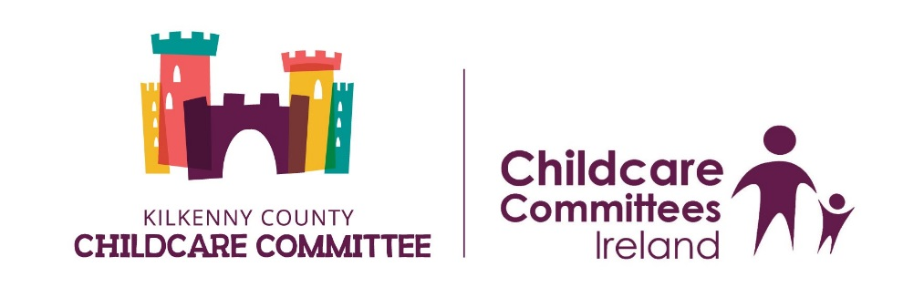

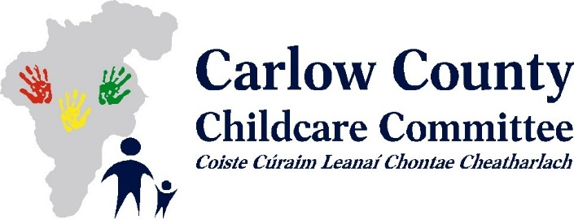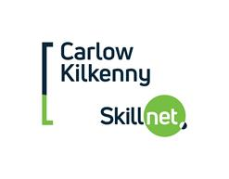

**Launch of Bachelor of Arts in Applied Early Childhood Education and Care Level 7 in Carlow for September 2021**

Institute of Technology Carlow in partnership with Carlow and Kilkenny County Childcare Committees will be offering a Level 7 Bachelor of Arts in Applied Early Childhood Education and Care starting in Carlow (at IT Carlow) in September 2021.

This Bachelor of Arts in Applied Early Childhood Education and Care programme which is part funded by *Carlow-Kilkenny Skillnet* and is designed for those who hold a FULL QQI Level 6 major award in childcare and who are working full-time in the sector with at least 3 years’ full time experience.

If you are interested in enrolling on this Bachelor of Arts in Applied Early Childhood Education and Care programme, please complete the application form and return to Carlow Kilkenny Skillnet, Carlow Gateway Business Centre, Athy Road, Carlow or emailed to [admin@carlowkilkennyskillnet.ie](mailto:admin@carlowkilkennyskillnet.ie)

before **4pm on Friday 5th March 2021.**

If you have queries please contact Carlow/Kilkenny Skillnet on 059-9132152.