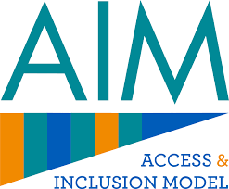

A Model for Supporting Access to Early Childhood Care and Education (ECCE) Programme for Children



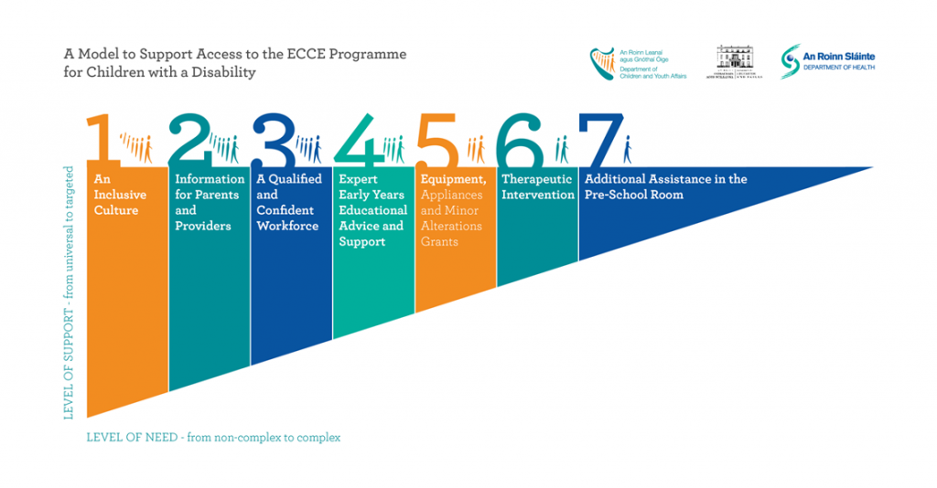

For additional information contact https://aim.gov.ie/aim-supports/targeted-supports/