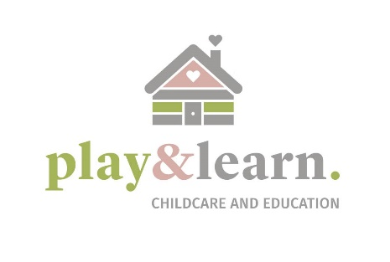
Play and Learn Childcare & Education are hiring a part time and full-time early years educator for our Bagenalstown branch!
What we offer:
Competitive salary
Opportunities for Career Progression
Paid non-contact time
A high-quality learning environment with a fully complaint Tulsa inspection.
Free childcare for school aged children and discounted childcare for under 5's.
Employee wellness program which includes 24/7 access to therapists, financial advisors and legal advisors. There are also 6 free counselling sessions per employee per year.
The candidate should have:
A minimum level 5 QQI qualification in early childhood education and care
A genuine love and interest for working with children
Excellent communication and interpersonal skills
Excellent level of spoken English
An ability to work as part of team
An ability to work in partnership with parents and other educators within the centre to create a home from home environment.
Job Type: Permanent
Salary: €12.00-€14.00 per hour
Benefits:
- Childcare
- Company events
- On-site parking
- Wellness program
Schedule:
- Monday to Friday
Licence/Certification:
- FETAC/QQI Level 5, 6, 7, 8 or 9 (required).

hello@playandlearn.ie bookings@playandlearn.ie

Citywest: citywest@ playandlearn rn.ie I 086 079 0054 Newbridge: newb ridge@ playa n dlearn.ie I 085 859 6622
Bagenalstown: bagenalstown@ playandlearn rn.ie I 083 031 2345 I 059 97 20567

